|  |  |
| --- | --- |
| NAME OF INTERN | Marcus Yeo YaoHeng |
| NAME OF DSO SUPERVISOR | Koh Hang Kiat, Simon |
| DATE OF INTERNSHIP | 08/05/2023 – 28/07/2023 |

1. Overview of your internship assignment

During my internship, I undertook the exciting project of creating an Intelligent Chatbot Assistant for the ES Division as part of a larger application. The goal was to provide a user-friendly solution for handling queries and deriving insights from an analytical tool backed by a database, without the need for complex UI/UX processes.

As part of the requirements of the chatbot, it has to be able to hold basic conversations with users, as well as perform data retrieval via querying a local SQLite database and perform summarization tasks (flow illustrated below). A proxy use case, and ultimately what I modelled my chatbot after, would be that of a superstore app that has customer and staff modes. A customer might be interested in finding out all the unique brands available, the prices of certain products, or what products are in stock by a particular brand. Customers would then be able to use this chatbot to make their queries as if they were using a search engine. After inputting their query, the chatbot would then parse and rationalize it through the NLU component and query the SQLite database before returning the desired result. On the other hand, the staff mode would have functions unavailable to the customer, such as the ability to see transaction data or confidential information. This provides a wide range of functionalities to different groups of users who might want to access the same data while at the same time restricting certain information to particular user groups.

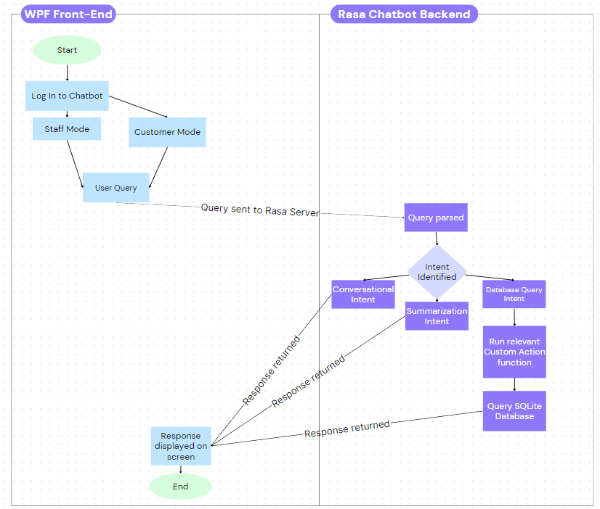

Flowchart representing how a query is processed by the Rasa Chatbot

To begin my project, I conducted extensive research on various chatbot frameworks and engines. This involved delving into the underlying principles of chatbots and understanding how Natural Language Processing (NLP) is applied. Considering the project requirements, such as the need for an offline chatbot capable of querying a SQLite database and performing keyword and semantic searches, I carefully evaluated different open-market frameworks like GPT-3, Botpress, ChatterBot, and Rasa. After thorough consideration, I decided to utilize the Rasa framework. Having previous experience with Rasa and recognizing its versatility and powerful NLU component, it emerged as the ideal choice for this project.

With the framework selected, I dove into the Rasa documentation, which proved vital in comprehending the inner workings of the chatbot and designing the software architecture. I meticulously crafted numerous use-cases, known as "stories", and user inputs, referred to as "intents." This planning stage was critical as these would serve as training data, enhancing the accuracy of intent classification within the NLU component. Additionally, I carefully devised conversation flows and planned the chatbot's responses, or "utters," to ensure a smooth implementation in later stages.

Once I had developed an extensive set of intentions, stories, and utters, I proceeded to build the prototype chatbot. This was where I encountered my first challenge – implementation of custom actions, which involved the integration of SQL queries to interface with the database and retrieve relevant user query results. Through persistence and multiple attempts, I successfully connected to the local database, enabling rasa to accept user inputs and accurately display the results on the terminal.

The next hurdle was integrating Rasa with a WPF C# front-end to offer a more user-friendly interface. I overcame this challenge by tinkering with the REST API of Rasa, allowing for seamless connection with the chatbot once a local server was set up. However, there were complexities in parsing the output from Rasa and converting the returned JSON string containing the table schema, into a presentable table to be displayed on the WPF App. This was eventually overcome through multiple revisions of how data was returned by Rasa and how it was interpreted by the WPF App.

After successfully setting up the chatbot, I then proceeded to further refine the WPF App and expanded the chatbot's use-case repertoire. Regular updates to the chatbot's corpus effectively enhanced its intent recognition capabilities. Additionally, I also improved the user interface, making it more visually appealing and intuitive, as well as incorporated some quality-of-life (QOL) features to maximize user convenience.

1. Technical Report of Chatbot Application
   1. Literature Review

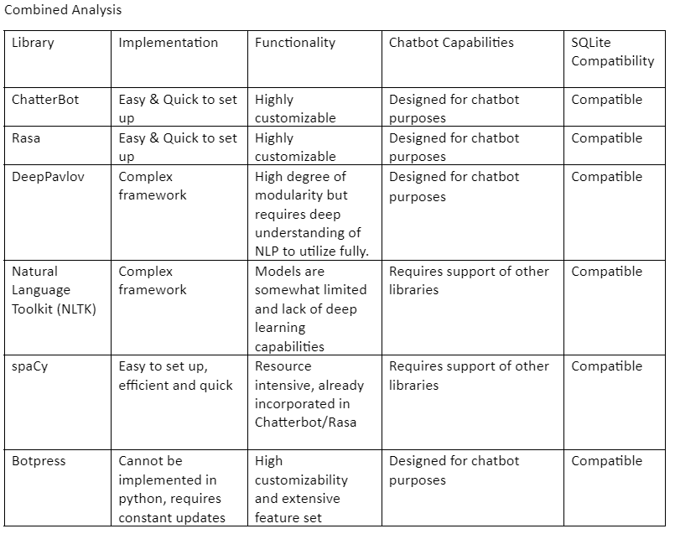

Table comparing the pros and cons of utilizing different chatbot engines for the project

During the literature review, I investigated 6 different publicly available chatbot engines to assess their feasibility for use in the project. From my extensive research, most chatbots fulfilled the criteria of functionality and SQLite compatibility. However, not all of them were feasible to implement and could carry out basic chatbot capabilities, which were the basic criteria for the project. As a result, I decided to choose the Rasa framework, as not only did it meet all the requirements, the documentation was thorough and the framework is still being actively maintained, promoting future extensibility. I also had prior experience working with the framework, which was a bonus since it would flatten the learning curve for me.

* 1. Story/Rule implementation
     1. Story Implementation

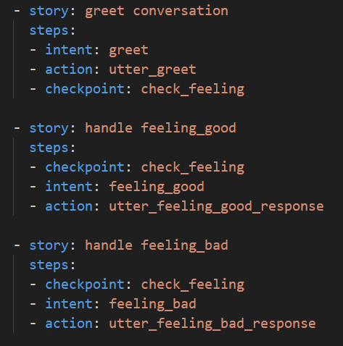

Stories implementing a greeting conversational flow. Checkpoints are used to account for different user responses

Stories are the fundamental structures that help the Rasa chatbot identify flows in conversations, identify intents and indicate to the chatbot what to do next. As part of the chatbot, it was crucial that the bot would be able to handle simple conversational flows and converse with the user naturally. This meant that for every use case, conversations had to be storyboarded and planned ahead of time. Intents (user inputs/intentions) and utters (bot responses) had to be meticulously planned out, accounting for different responses and contexts which is accounted for using Checkpoints, which the bot will consider when deciding what to do next. These stories are then implemented in the stories.yml file of the bot.

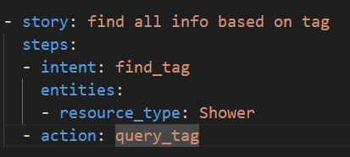

Story to find all data of products based on their associated tag

Stories need not be static conversations. They can also indicate important information that need to be stored as entities to be processed later. This can be seen in the above story, where the user intent find_tag would contain a tag which we are trying to store as an entity resource_type. This is one of the ways we aid the bot in entity recognition.

* + 1. Rule Implementation

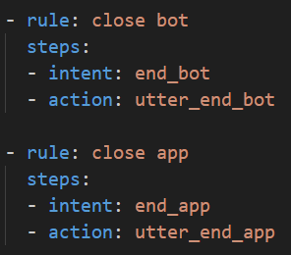

Rules for the closing of the chatbot and the WPF application

Rules are a more rigid version of a story. Rules clearly lay out the steps to follow if a particular intent is identified and are implemented to indicate to the chatbot that these are important conversation flows and should be prioritized. When parsing for conversational flows, the chatbot will always prioritize rules over stories and if an intent is identified which matches that of a rule, the rule will always be acted on first.

* 1. Intent implementation

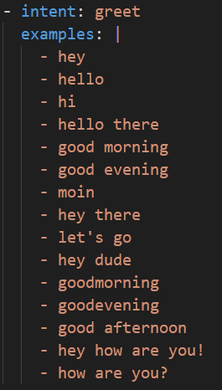

Greet intent with its associated training data

Intents help the chatbot identify and classify user inputs. They are then used in Stories to decide what to do or how to respond accordingly. Implementing stories allows the chatbot to ‘understand’ what the user has input and the examples are a corpus of potential inputs that could be classified under the intent. When training the chatbot, the NLU module will be trained with this data, and if it identifies the input as being similar to the examples, will classify the input as a particular intent with a certain confidence rating. It is hence recommended to have a large and updated corpus to aid accurate intent recognition.

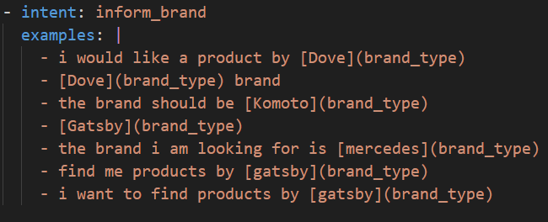

Inform_brand intent with its associated training data, identifying the entity to be retrieved.

Intents can do more than just identifying user inputs. Intents can also be used to indicate important information to be stored as entities. This is important if we want to make use of information in the user’s inputs for later. For intents, the important information is indicated in hard brackets [] and the entity type is indicated in soft brackets (). This aids the chatbot in identifying entities and makes it possible for the chatbot to parse any custom user input that may not be in the examples and identify the entity and store it correctly.

* 1. Slot/Entity implementation

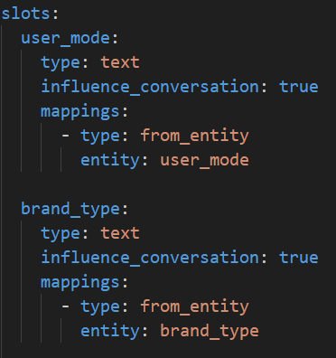

Entity Slot implementation for user_mode and brand_type

Before intents can be parsed for entities, there is a need to declare them in the domain.yml file. This indicates the names of the different slots, their data type and if they should influence conversations. Once implemented, these slots will act as variables when the bot is running, storing values when they are identified which can be constantly referred to until they are overwritten or the bot is shut down.

* 1. Custom Action Implementation

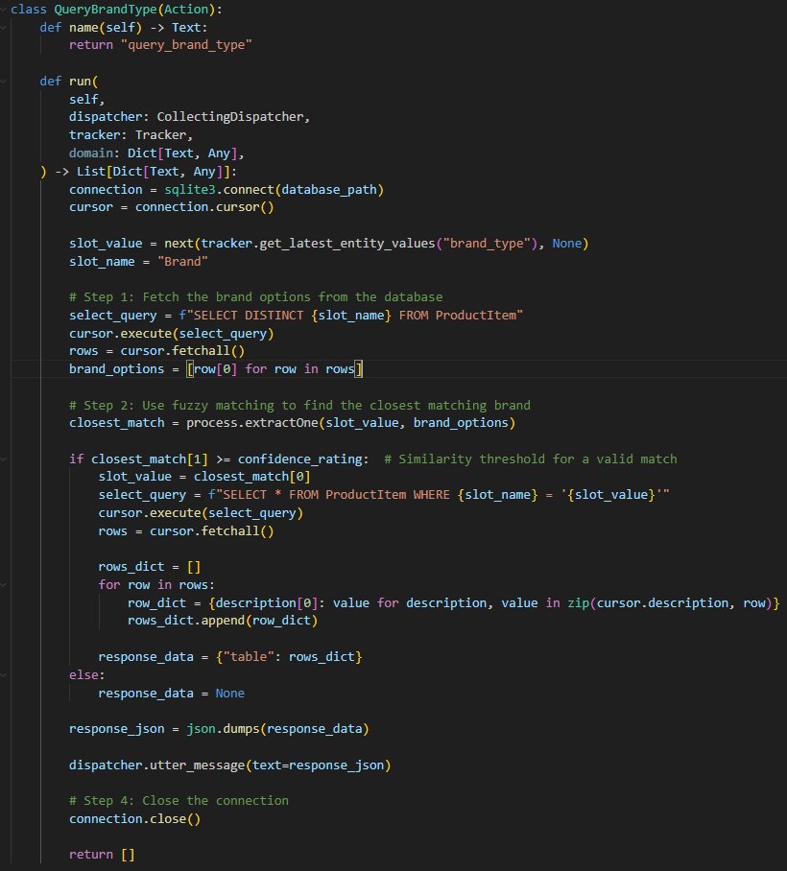

Custom action for query_brand_type

Custom Actions allow for one of the core functionalities of the bot to work. When the bot predicts that the user is trying to query the database, it will use stories and rules to determine what exactly is the query. This will trigger the corresponding custom action to query the SQLite Database and return the response. To allow for better responses, fuzzy matching is incorporated in some custom actions to account for potential misspellings. After obtaining the resulting schema from the SQLite database, we then format it into a JSON string, which is needed for the WPF front end to display the results in a table format.

* 1. Endpoint Implementation

In order to activate the Custom Actions, there is a need to activate the action_endpoint under the endpoints.yml file. Doing so sets up the rasa Custom Actions server at localhost:5055. In order to connect the WPF to the Rasa, I made use of the REST API, which is the general purpose connection and the recommended connection for Rasa.

* 1. WPF Implementation

Throughout the development of the WPF app, I picked up many new skills which enabled me to build a functional interface to use the chatbot.

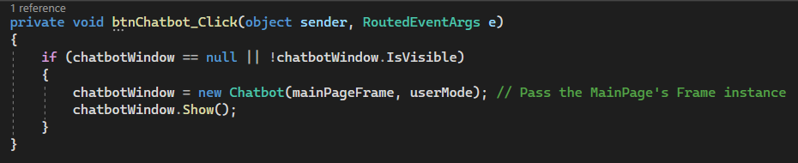

I learned to use pages and windows effectively and manipulate the way they are displayed through passing frames and playing with .Show() and .ShowDialog(). This allowed for greater utility of my application, greatly enhancing the user experience.

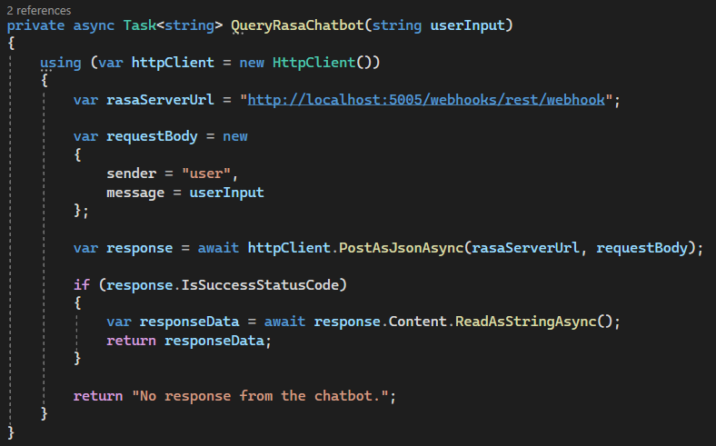

In order to connect to the Rasa chatbot, a method had to be created to interface with the chatbot’s REST api. This allowed for seamless and quick interactions between the front end and back end, improving the performance of the application as a whole. The formatting of the responses and inputs to the chatbot also took some time to understand and implement in order to ensure that the correct inputs and results were sent through.

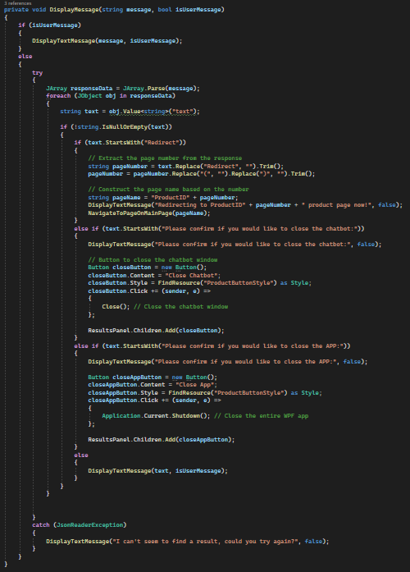

Lastly, the implementation of displayMessage took some effort to get right due to the large amount of use cases which this had to accommodate, hence the length of the method. The use of formatting and parsing the JSON string from the chatbot also required a lot of persistence to get right and display properly on the screen.  
_____________________________________________________________________________________

1. Challenges faced during your internship/traineeship/attachment

During my internship, I encountered several challenges that tested my skills and required problem-solving. Here are the key challenges I faced:

1. Lack of experience with Rasa and NLP/NLU: One of the major challenges was my limited experience with Rasa and the concepts of NLP and NLU. As the project involved building a chatbot from scratch, I had to invest significant time and effort in self-learning. Through thorough research, studying the Rasa documentation, and watching tutorials, I quickly gained the necessary knowledge and skills to work effectively with Rasa and understand its functionalities.
2. Connecting Rasa to the WPF App: Integrating Rasa with the WPF App posed a challenge due to limited online resources for the specific version I was working with. The lack of information on connecting external clients to the Rasa API made it difficult to establish a connection. I had to experiment, perform trial and error, and extensively study the endpoint.yml file to successfully connect the WPF App to Rasa's API.
3. Displaying results as a chart in the WPF App: As part of the basic functionalities of the chatbot, I was tasked with creating a function which would present returned data as a chart within the WPF App. My limited experience with Rasa and unfamiliarity with the WPF led to errors when parsing the data. This resulted in errors when displaying the graph and affected how the data was displayed. Simple information such as the ordering of date-time formats had to be done manually so that they could be properly displayed as the X axis. However, after multiple attempts and making adjustments to the data format returned by Rasa, I managed to overcome the challenges and successfully display the information in the desired chart form.

These challenges allowed me to gain valuable experience and enhance my problem-solving abilities. By immersing myself in self-learning, conducting thorough research, and persistently experimenting, I was able to overcome these obstacles.

1. Lessons learnt from the tasks assigned to you

From the tasks assigned to me during my internship, I gained valuable lessons that have had a lasting impact on my professional growth. Here are some of the key lessons I learned:

1. The significance of conducting a thorough literature review and research: Before starting my internship, I had a preconceived notion about using the ChatterBot framework based on a recommendation from a friend. However, as part of the project requirements, I was required to conduct extensive research on various other chatbot frameworks. This process exposed the disadvantages of ChatterBot, such as its limited modularity and steep learning curve. It also introduced me to the advantages of the Rasa framework, which ultimately proved to be the optimal choice for the project. This experience emphasized the importance of conducting a comprehensive literature review and research before diving into a project. It taught me the value of exploring multiple options and understanding their pros and cons, enabling me to make informed decisions that can bring greater benefits in the long run.
2. The power of self-learning and resourcefulness: Throughout the internship, I encountered challenges that required me to learn new skills and technologies independently. From understanding the fundamentals of NLP and NLU to integrating Rasa with the WPF App, I had to rely on self-learning resources, such as the Rasa documentation and online tutorials. This experience taught me the importance of being resourceful, proactive, and self-motivated in acquiring new knowledge and skills. It highlighted the significance of continuously seeking out learning opportunities, even in unfamiliar domains, to overcome challenges and deliver successful outcomes.

Overall, the tasks assigned to me during my internship provided valuable lessons that have shaped my approach to future projects. I now recognize the significance of conducting thorough research, being resourceful in acquiring new skills, and maintaining persistence and problem-solving abilities.

1. Positive experiences in DSO

During my time at DSO, I have had several positive experiences that have contributed to a pleasant and welcoming environment. Despite the remote nature of my work, I have had the opportunity to connect with other interns in the same department. Interacting with them has allowed me to settle in easier. Seeing familiar faces around when coming back to office has provided a support system, and we often check in with each other on our progress and share experiences, making the work environment more enjoyable.

From the very beginning, DSO has made an effort to ensure that interns feel welcome and supported. The first-day welcoming activities and gestures have been a nice touch, helping to create a positive first impression. Moreover, coworkers in my department have been patient and accommodating, always ready to assist and provide guidance. Their open and helpful nature has made it easier for me to navigate through challenges I faced during my internship, such as how to enable my application to be used on the technet, which made my work a lot easier. I am grateful for their willingness to lend a hand.

In summary, my experiences at DSO have been very positive. The opportunity to connect with fellow interns, the welcoming and supportive environment, and the overall care shown towards interns have all contributed to a pleasant work experience. This has allowed me to settle in smoothly and become as productive thanks to the support I have received throughout my internship.

1. Areas to improve

In my opinion, there are some areas that can be improved such as the laptops provided to the interns. The laptop I was issued is a Thinkpad which although worked, was very slow when connecting to the internet or doing simple tasks like refreshing emails. The small screen and keyboard also made it unconducive for coding. The biggest issue with the computer was when downloading applications, which due to the security software installed, caused download times to increase drastically, resulting in many wasted hours of waiting for software to be installed.

Another area that could be improved would be the locations assigned to interns. From my understanding, the large amount of interns this summer meant that there was not enough space in the intern room to house everyone. This resulted in some interns like myself being allocated to work in a small conference room with 8 other interns. The small room combined with the lack separate desks made working there very hard as there would be barely any space when everyone was at the office such as on the first day. Working there also made us feel quite isolated from the other interns.

1. Changes that you would recommend

Some changes that I would recommend would be to provide faster laptops with a larger screen. For interns doing coding projects, ideally a keyboard and a monitor could be issued to them to better allow them to complete their work.

Interns could also be issued their own desk and locker instead of being allocated into a meeting room, which would go a long way to helping them settle down and providing them a conducive environment to work.

1. How the project / research can be applied to DSO/Div’s mission and vision

**DSO Mission:** To develop technologies and solutions that can provide technological surprises to sharpen the cutting edge of Singapore's national security.

**DSO Vision:** To be a wellspring of technological knowledge, a fountain of innovation and an inspiration to the R&D community in Singapore.

**ES Div Mission:** The Electronic Systems Division advances electronic warfare systems with radio frequency and micro-electronics technologies and provides electromagnetic superiority.

In my opinion, my project has several applications that align with the mission and vision of DSO and the ES Division. Although the project does not directly contribute to the ES vision, it definitely supports it through enhancing the user analysis tool by streamlining information retrieval and analysis processes. Operators and analysts can utilize the chatbot to quickly retrieve critical data, obtain summarized insights, and make informed decisions in the context of electronic warfare operations. This contributes to the division's objective of achieving technological excellence in electronic warfare systems and maintaining electromagnetic superiority.

This project can also be applied to DSO’s vision and mission. For example, the chatbot can serve as a repository of technological knowledge within DSO and the ES Division. It can accumulate and access a vast amount of information, including project details, inventory status, and reports. This knowledge base can be accessed by all members of the organization, with restrictions put in place for different security clearances, making it a secure and valuable resource for decision-making and problem-solving within DSO.

By providing quick and accurate information retrieval and summarization capabilities, the chatbot streamlines tasks and improves efficiency for both customers and staff members. This contributes to DSO's mission to provide technological solutions that enhance productivity and effectiveness.

1. Whether your initial expectations have been met

My initial expectations have definitely been met. When I first joined, I had high expectations regarding the learning opportunities available at DSO, particularly in the field of emerging technologies and national security. I am pleased to say that my internship has provided ample opportunities for learning and skill development. From working on the chatbot project to exploring different frameworks and technologies, I have gained valuable knowledge and practical experience. The exposure to real-world challenges and the guidance provided by mentors and colleagues have significantly contributed to my professional growth.

1. Thoughts about your supervisor

I am extremely grateful for the exceptional organizational skills and support provided by my internship supervisor, Simon, during my time at DSO. His meticulous planning, clear instructions, and the provision of a project timeline made it easy for me to integrate and hit the ground running in a new working environment.

Alongside his organizational skills, Simon has consistently provided supportive guidance throughout the internship. He is always readily available to address any questions or concerns I have, offering valuable insights and suggestions to enhance my work. This has created a collaborative atmosphere where I felt comfortable seeking advice and feedback. Simon’s supportive guidance has not only helped me overcome challenges but has also fostered my professional growth and development. I am truly grateful for his commitment to ensuring my success and making my internship journey at DSO a fulfilling and rewarding one.

1. Thoughts on your future career

My internship experience at DSO has had a profound impact on my future career aspirations. The exposure to working with NLU models and gaining experience coding in C# and python have boosted my confidence as a Software Engineer. Through the challenging tasks and responsibilities assigned to me during my internship, I have grown significantly in terms of technical skills and problem-solving abilities. The guidance and support provided by my colleagues and supervisor have also helped me become more confident in my capabilities, which will undoubtedly benefit my future career endeavors.

The exposure to NLP and NLU during my internship has sparked a keen interest in this field. Working on the chatbot has allowed me to explore different NLU frameworks and gain greater understanding about the principles behind NLP. This has given me a glimpse into the fascinating world of NLP and I am very keen to learn more. The potential to develop intelligent systems that can understand and interact with humans in a natural and meaningful way has captivated my curiosity. In the immediate future, I intend to expand my knowledge in NLP and NLU by exploring advanced concepts, pursuing relevant courses or certifications, and participating in research or development projects. By keeping updated on the latest technological advancements in the field, I hope to have the chance to pursue NLP and NLU development in my future career.